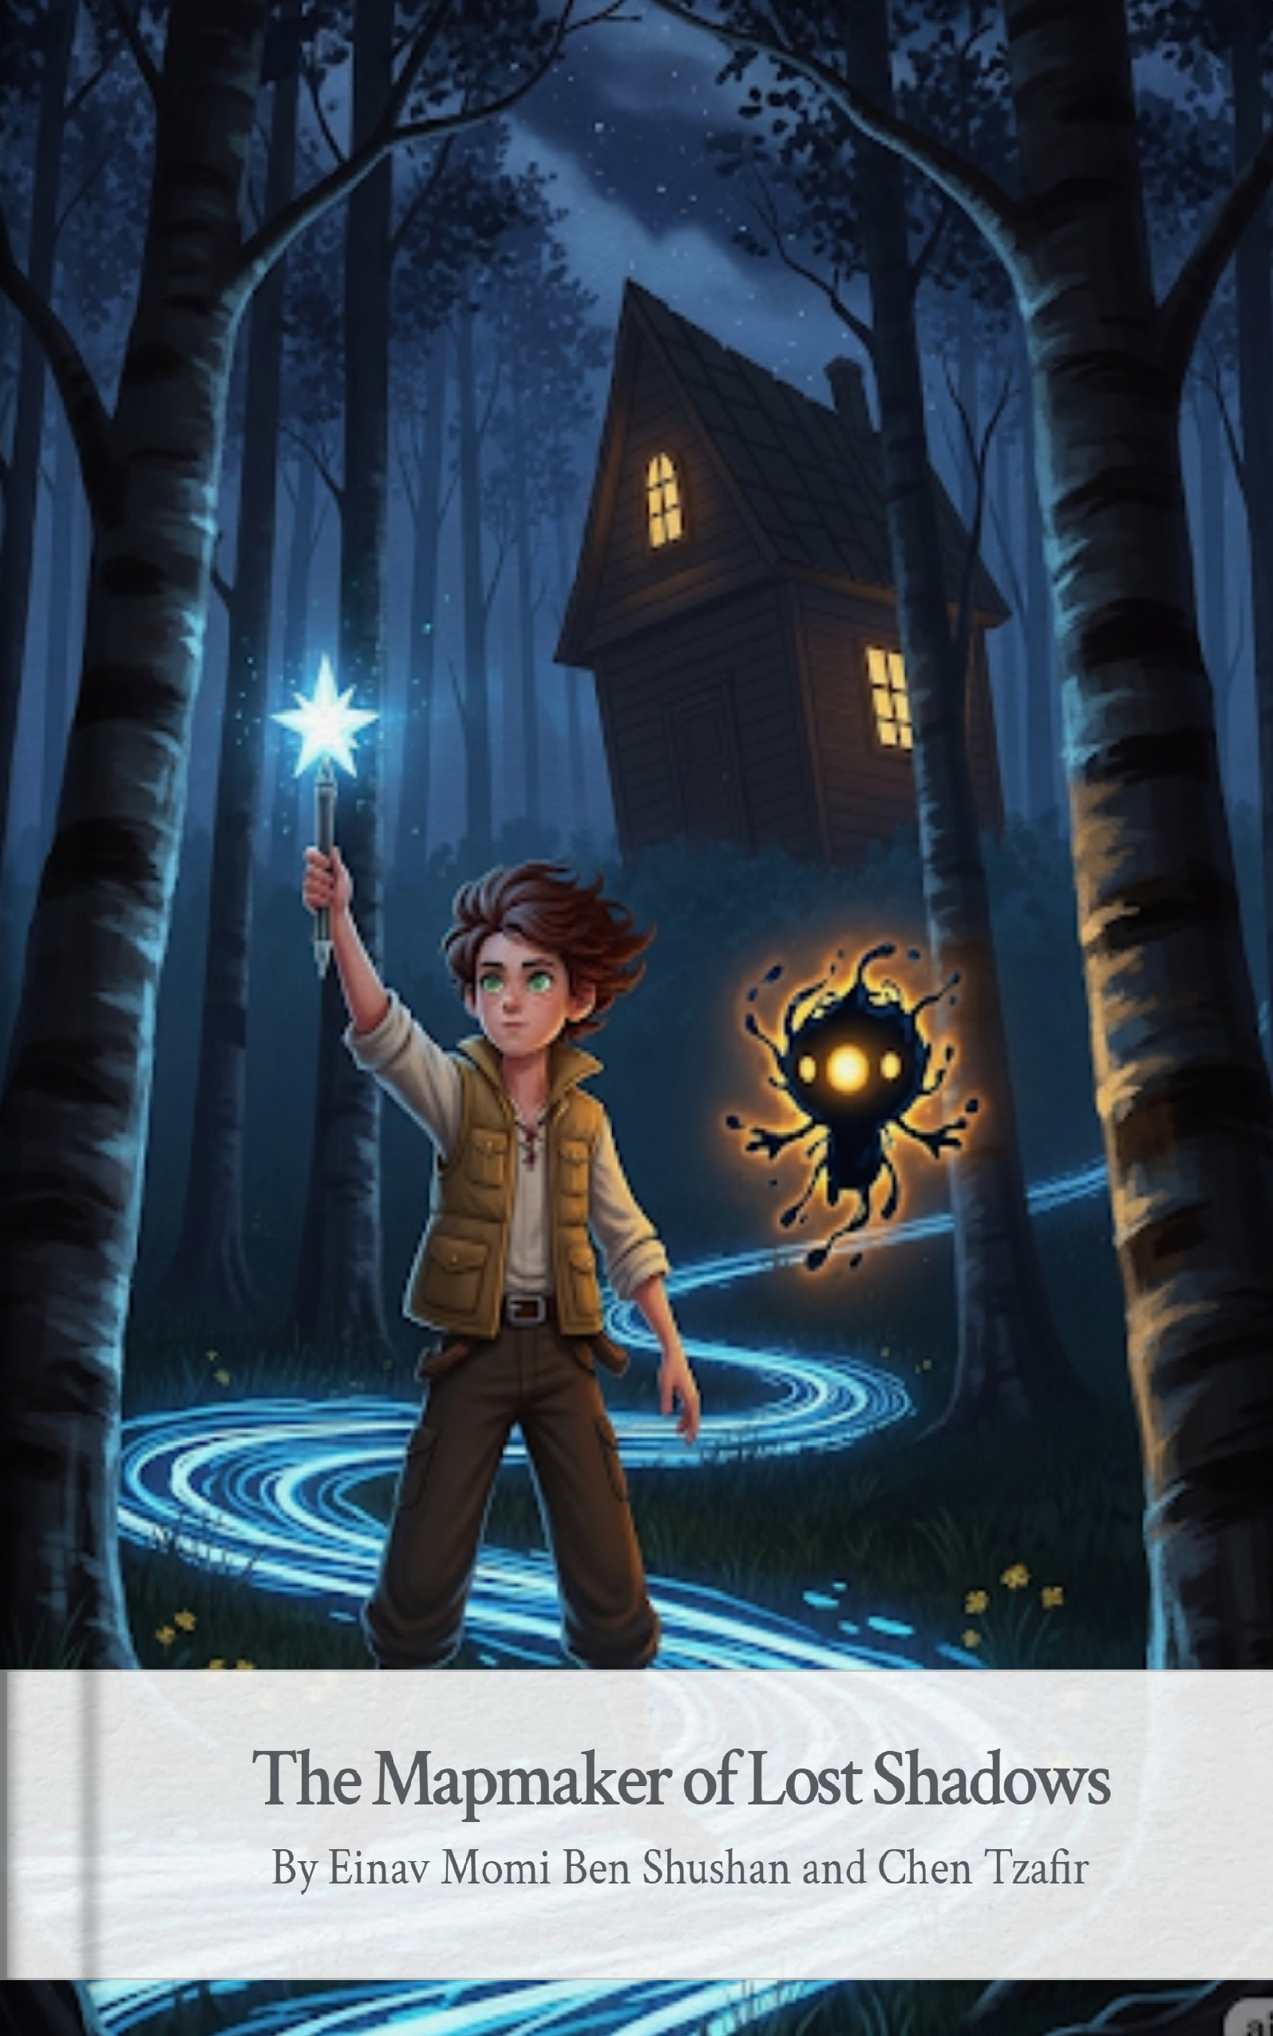
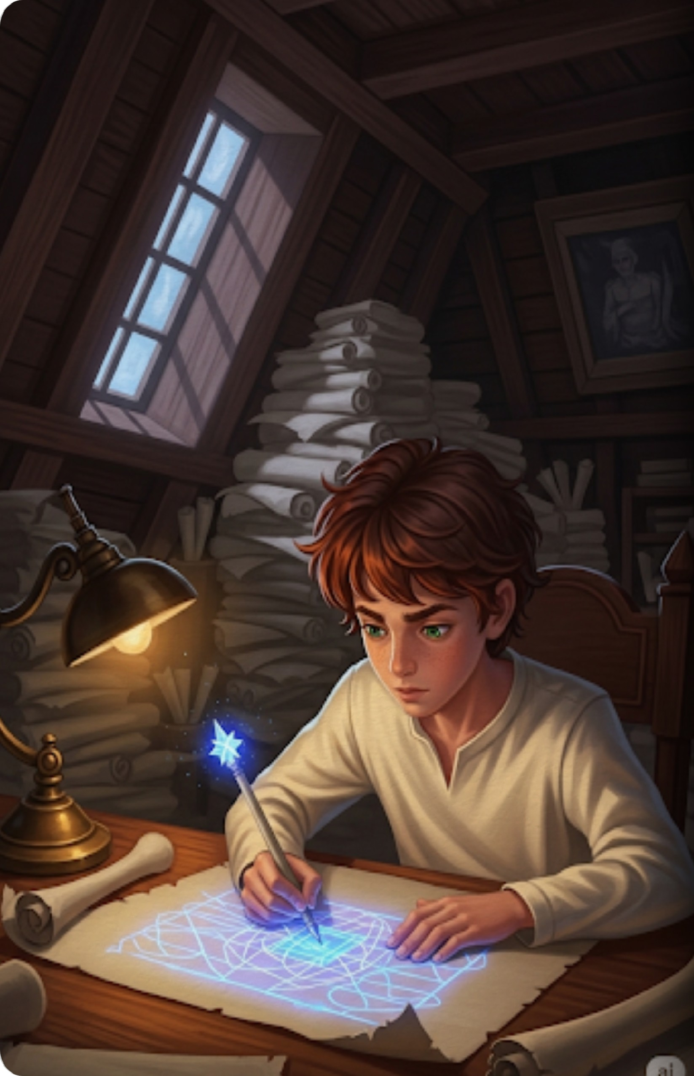
In the attic of a house that leaned against the wind, Azimuth sat surrounded by mountains of parchment. While the rest of the world slept in the light of the moon, he worked by the glow of his most prized possession: a pen carved from a fallen star. Azimuth wasn't a builder or a king, but he held a power just as great. He was the Mapmaker of Lost Shadows, the only one who could see the trails left behind when a shadow wandered away from its owner.
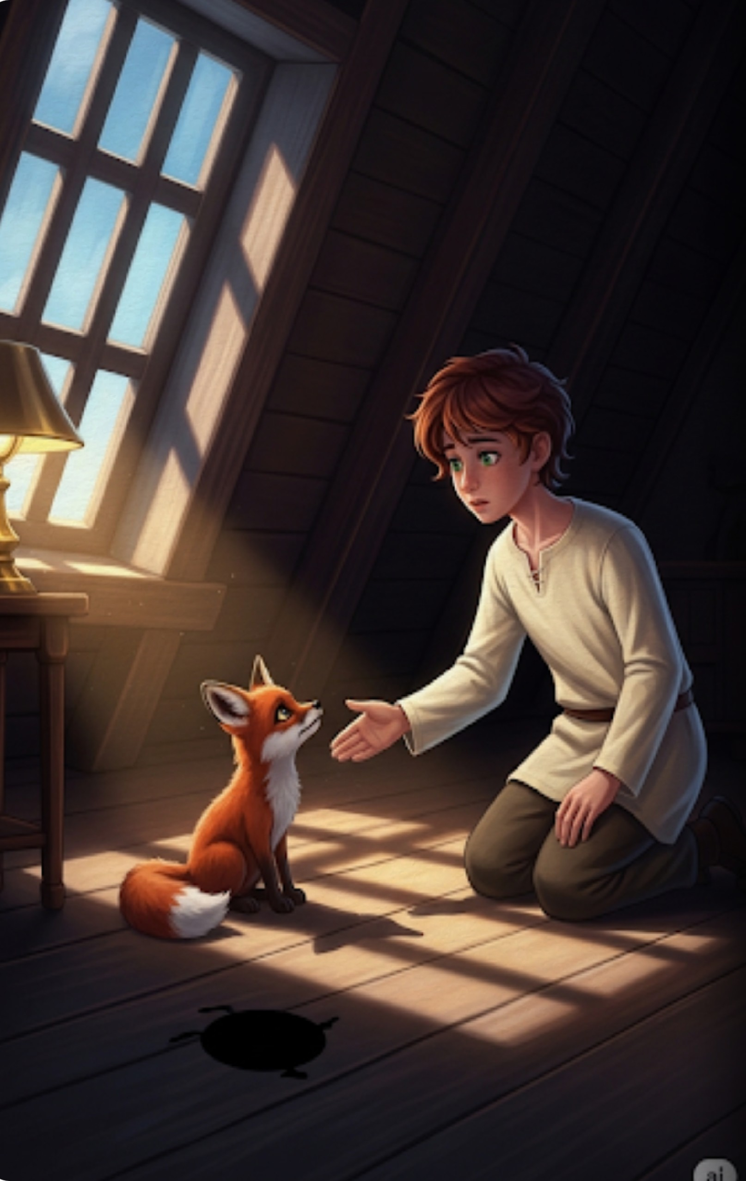
One evening, a small, shivering fox slipped through his window. It moved silently, but something was terribly wrong. As the fox stepped into the light of Azimuth's lamp, it cast no silhouette upon the floor. It was a "Hollow," a creature whose shadow had been snatched away. Azimuth knelt and reached out a hand. He knew that without a shadow, a creature would eventually fade into nothingness. "Don't worry," he whispered. "I'll find where it went."
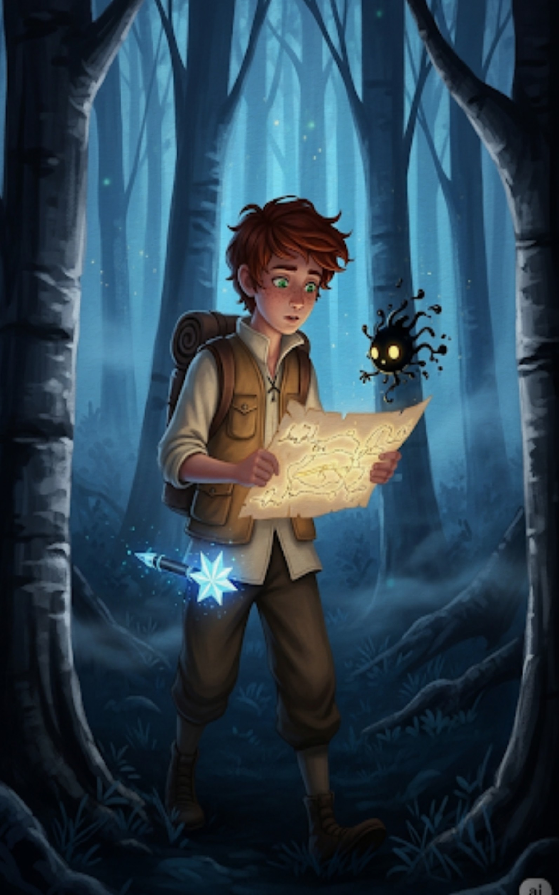
Azimuth strapped on his explorer's vest, filled his pockets with ink-stones, and stepped out into the night. Suddenly, a spark of light erupted from his pen. It wasn't just light; it was Nib, a tiny, floating spirit of pure ink and energy that served as his guide. Nib chirped a rhythmic sound, pointing toward the Whispering Woods. The ink on Azimuth's map began to swirl and move, forming a path that only the brave could follow.
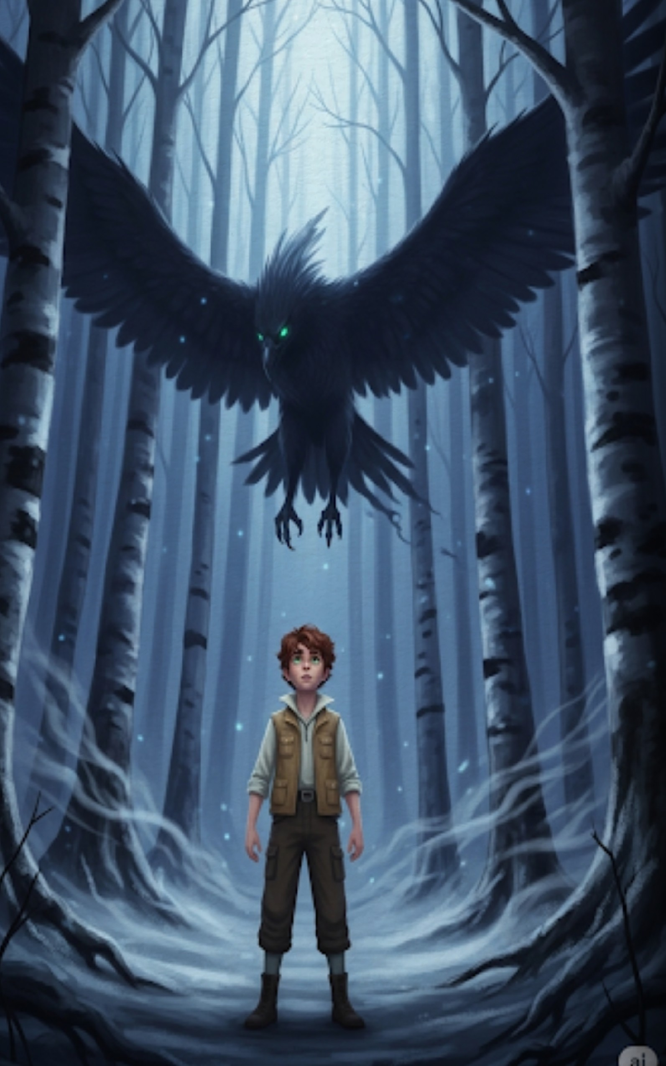
Deep in the woods, the air grew cold and the trees turned to silver. Azimuth looked up to see a magnificent sight— the Shadow Bird. It was a creature made of pure darkness, its wings spanning the width of the clearing. It wasn't a monster, but a lost soul, drifting aimlessly because it had no body to tether it to the earth. Azimuth realized the fox's shadow wasn't just lost; it was being pulled toward the Great Silence at the heart of the forest.
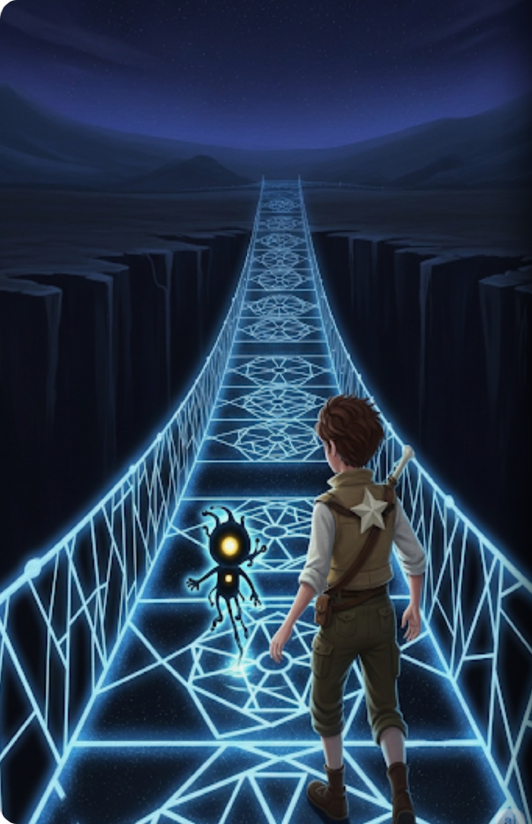
To reach the heart of the forest, Azimuth had to cross the Void Chasm, a place where the ground simply ended. He gripped his magical pen and began to draw in the empty air. Brilliant, glowing lines of ink solidified into a bridge of intricate patterns. Nib flew ahead, lighting the way as the ink bridge hummed with ancient magic. Azimuth stepped onto the glowing structure, his heart pounding against his ribs.
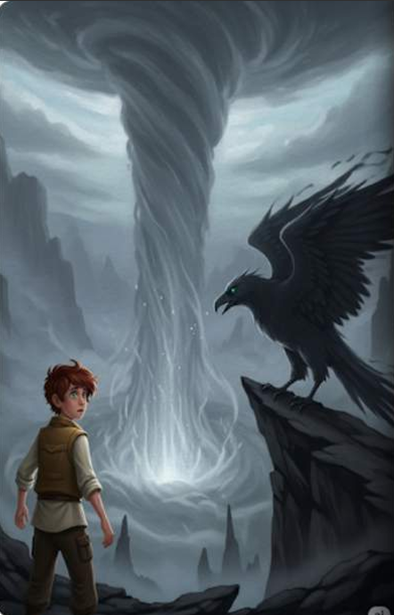
At the edge of the Chasm, the Shadow Bird landed. It let out a soundless cry, pointing its beak toward a towering mass of swirling grey mist—the Great Silence. This entity was a vacuum, a place where stories and shadows went to be forgotten. Azimuth saw hundreds of shadows trapped within the mist, flickering like dying candles. Among them, he spotted the frantic shape of the little fox's shadow.
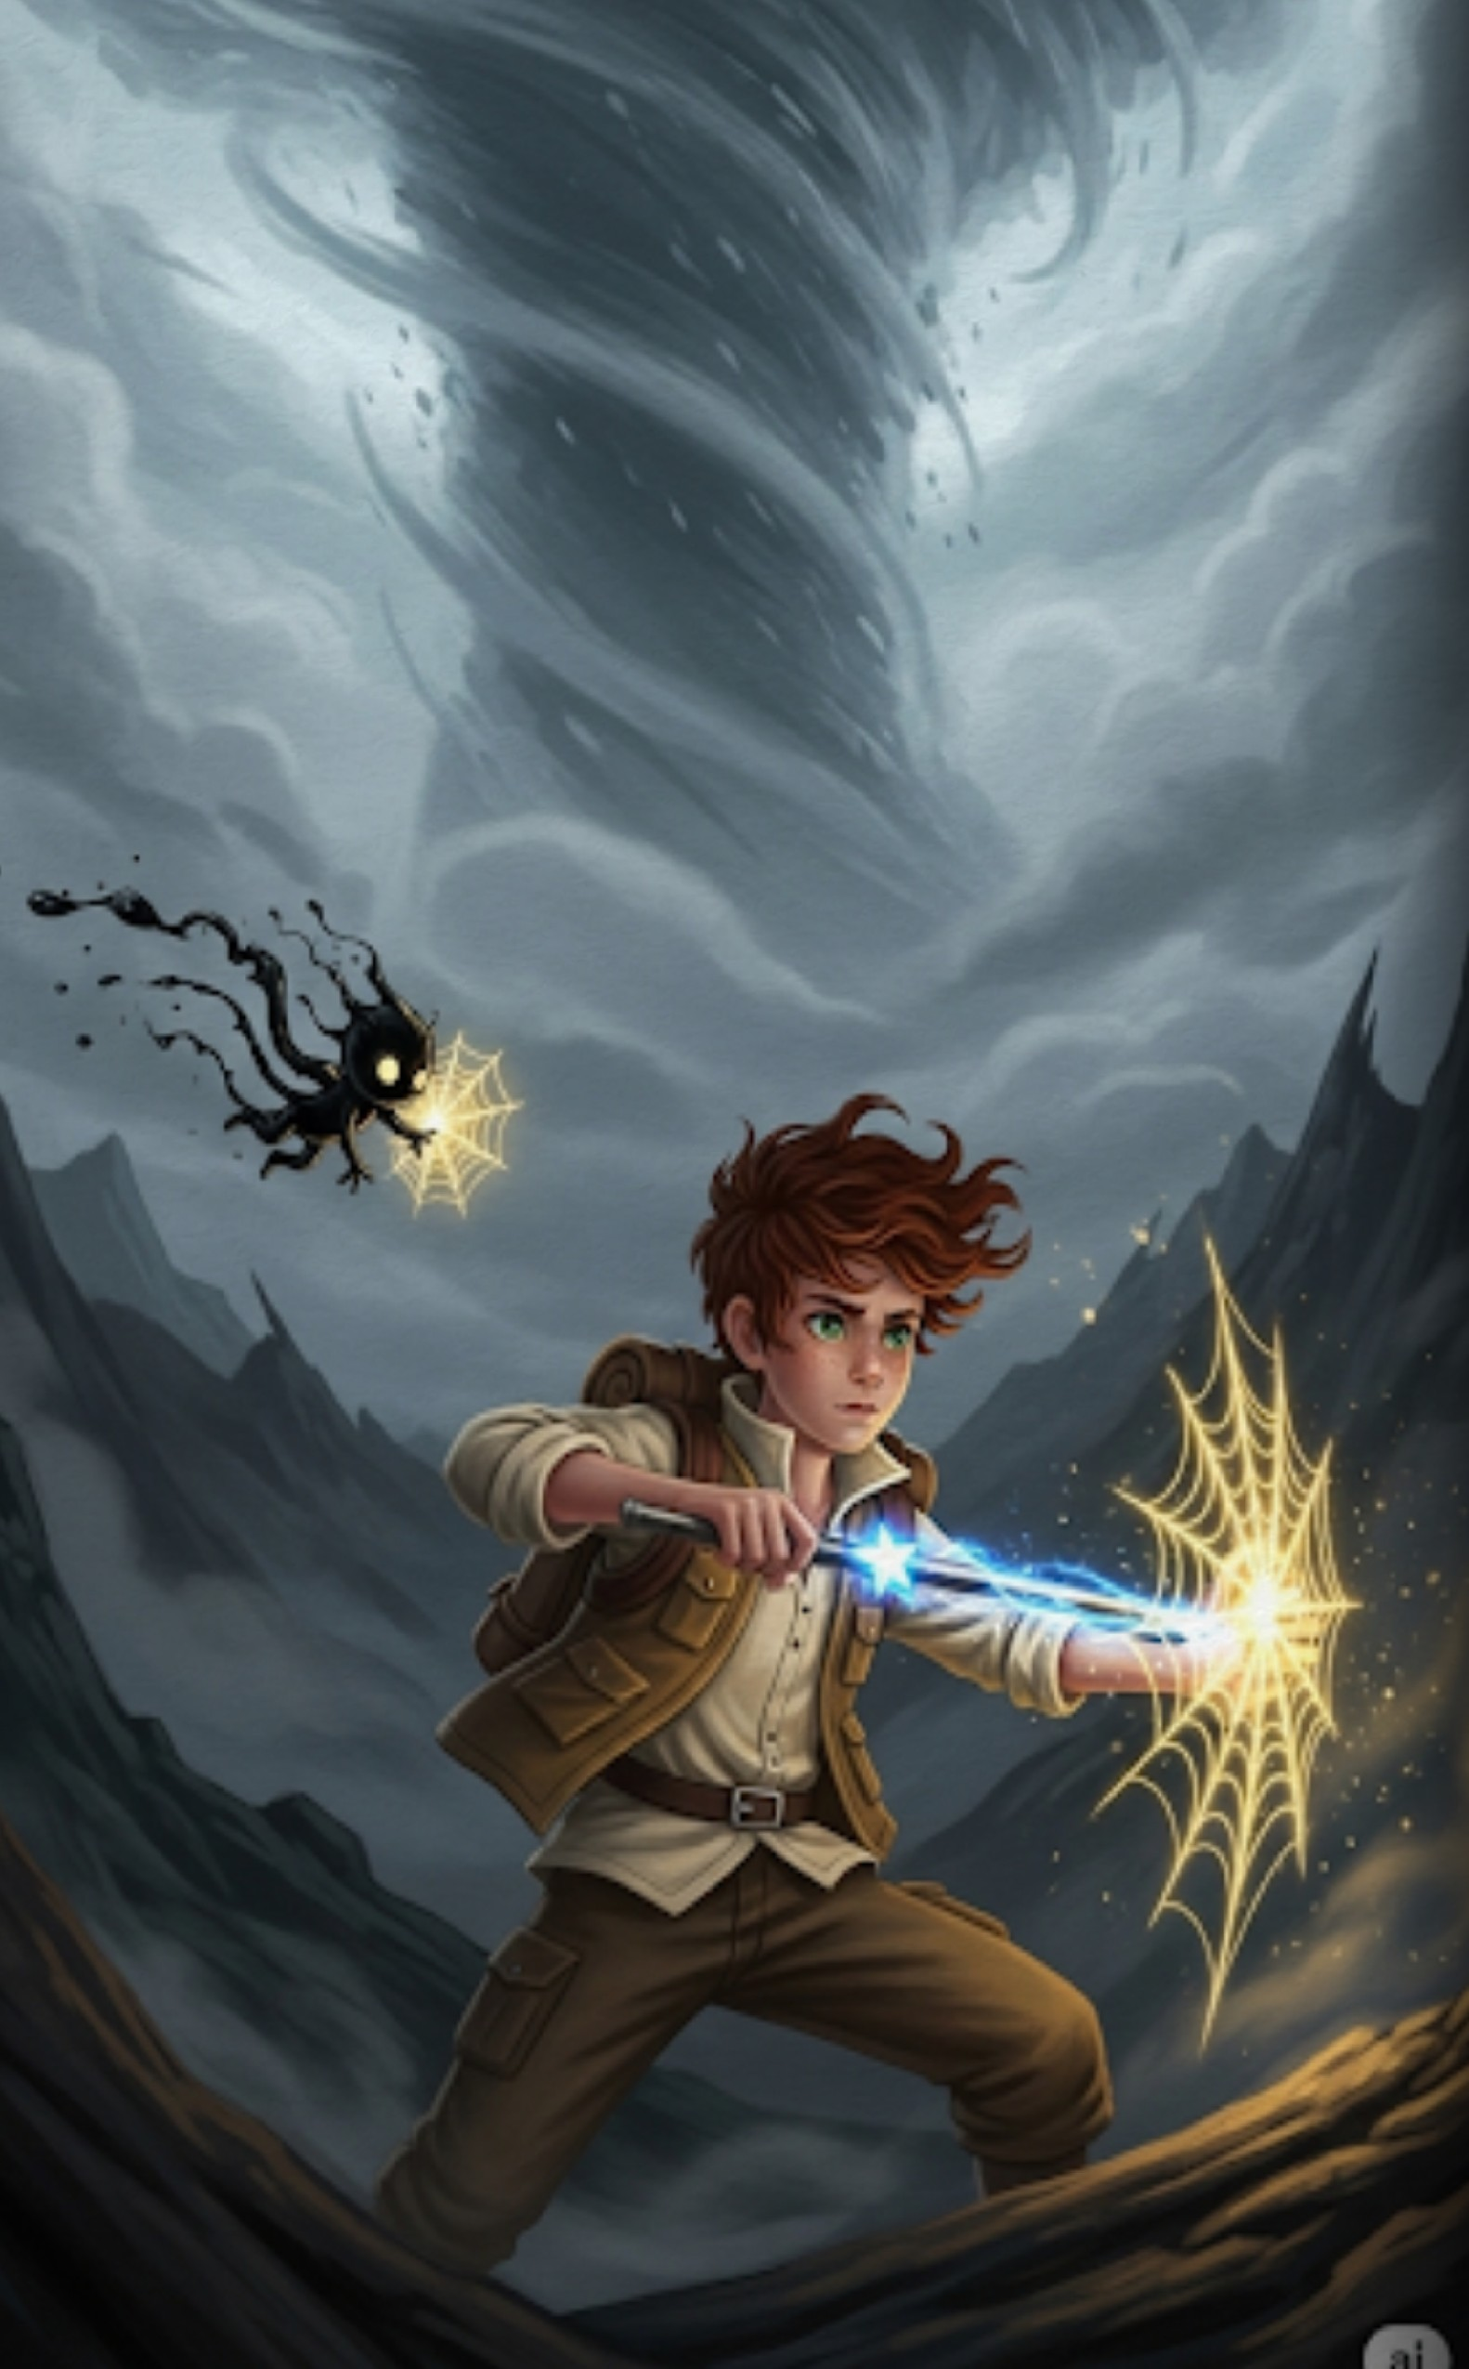
As Azimuth approached, the Great Silence lunged forward, trying to extinguish the glow of his pen. It hated the light of discovery. Nib darted back and forth, spinning a web of golden ink to shield Azimuth from the freezing touch of the mist. "Hold on, Nib!" Azimuth shouted, bracing himself against the wind. He realized he couldn't fight the silence with a sword; he had to fight it with a map.
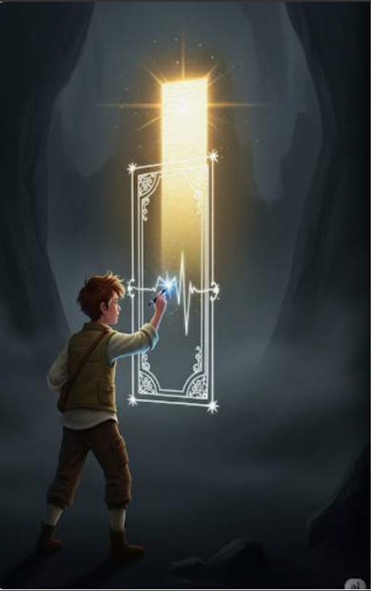
Azimuth pressed his pen against the very air and began to draw the most complex map of his life. He wasn't mapping a place, but a way home. He drew the memory of the fox's den, the warmth of the sun, and the sound of rustling leaves. As the lines connected, a brilliant door of light manifested in the center of the Great Silence. The ink pulsed with the rhythm of a heartbeat, calling to every lost shadow.
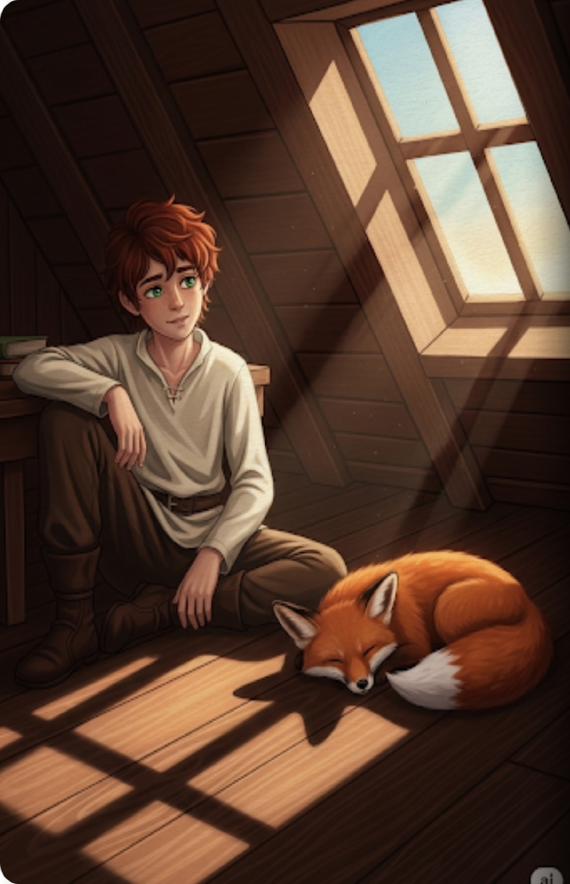
When the sun rose over the house that leaned against the wind, Azimuth was back in his attic. He was tired, but his heart was full. On the floor beside him, the little fox was curled up in a sunbeam, and beneath it lay a perfect, dark shadow. Azimuth picked up his pen and opened a fresh scroll, There were still many shadows lost in the world, and they were all waiting for a mapmaker to show them the way home.
10

